Record your talented singer, musician or band!

Create a professional quality CD
to last forever!

Share with family, friends & future generations.
Use your “Demo” for college or recital applications,
scholarships or getting gigs!

I can also help you take it to the next level
with 25 years as an award winning WB Records Rep.

I SPECIALIZE IN RECORDING
RIGHT IN YOUR OWN HOME!

For as little as $300, I will create a professional recording using ProTools “the studio standard”. I will record up to 4 hours (6 songs max) edit, mix, master and provide 3 CDs with professional quality graphics on the cover and the disc.

(Microphones: Neumann TLM-103, Akg 414, Shure SM7b)

$250 Special (for vocalist recording at my home studio)
$150 Special 2 song package also available.

I also record: Church groups, choirs & school bands

For more information and samples of my work:
www.ProteusMusicProductions.com

Contact: Jim Manfre - Hoffman Estates, IL
(847) 209-0999 JimManfre@yahoo.com

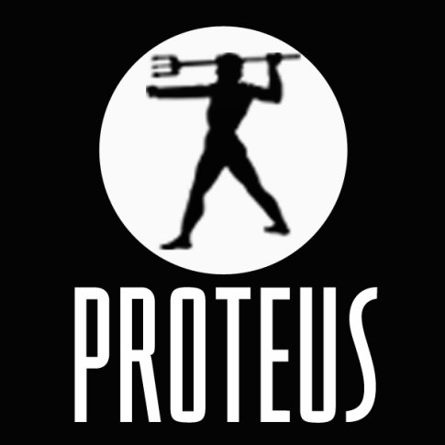

Proteus Music Productions
Production - Publishing – Marketing - Consulting

